**SMART AGRICULTURE SYSTEM BASED ON IOT**

1. **INTRODUCTION**
   1. **OVERVIEW**

India is an agricultural country. Agriculture is the backbone of our country. It is present in the country for thousands of years. India's agriculture is composed of many crops, with the foremost food staples being rice and wheat. India is currently the world's second largest producer of several dry fruits, agriculture-based textile raw materials, roots and tuber crops, pulses, farmed fish, eggs, coconut, sugarcane and numerous vegetables. India is ranked under the world's five largest producers of over 80% of agricultural produce items. Over the years it has developed and the use of new technologies and equipment has led to immense growth and better yield in agriculture. Our project uses smart technologies like IoT to help reduce the hard labor work of farmers. Advancements and innovations in technologies must be utilized to the full extent all industries and domains, that’s the main cause for the new developments and inventions.

* 1. **PURPOSE**

The aim of the project is to allow a farmer can operate the electrical motors to irrigate the field based on the data regardless of his presence in the field, which makes sure the crops are always properly watered and provides better yield. The farmer can know about the weather conditions of his field without actually being present in his field and take decisions like irrigating the crops around which time and the amount of water required for the irrigation. Based on the decisions he can remotely irrigate his fields from anywhere in the world.

1. **LITERATURE SURVEY**
   1. **EXISTING PROBLEM**

Indian agriculture is plagued by several problems; some of them are natural and some others are man-made. Of those, being unable to predict the climate and crop to be planted are the major problem. Also some of the other problems include soil erosion, lack of mechanization, irrigation, unpredictable monsoon. Awareness of soil quality testing is not done effectively in India and so the crop to be cultivated cannot be determined correctly resulting to loss of soil nutrients and minerals. ‘Gamble of Monsoon’ has been the most worry causing problem to Indian agriculture.

* 1. **PROPOSED SOLUTION**

There are new farming methods created now and then to increase the crop yield and better quality of crops. The solution proposed here is the usage of Cloud and IoT to monitor the soil and weather conditions. This project uses Temperature, Humidity and Soil moisture sensors to collect information and send it to the cloud platform. Then a web interface is developed for the farmer to interact and control the irrigation system. The farmer can visualize the information from the sensors. The weather forecast details will also be displayed in the web interface which makes it easy for the farmers to decide whether to irrigate the fields or not, for example when the forecast is saying like it is going to rain, the farmer need not irrigate his fields to avoid flooding in his field. Based on the forecast he can also determine how much quantity of water needs to be used for irrigation.

1. **THEORETICAL ANALYSIS**
   1. **BLOCK DIAGRAM**

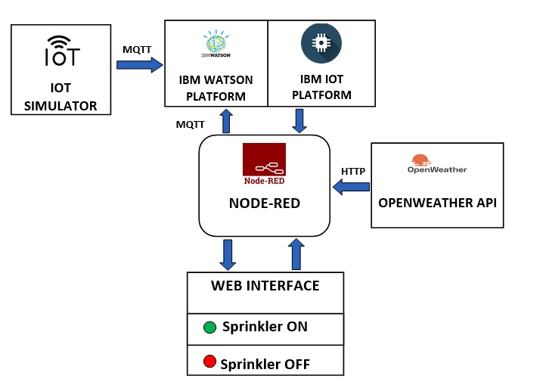

* 1. **HARDWARE / SOFTWARE DESIGN**

1. Set up the working environment. Install necessary software and create required accounts.
2. **Install latest version of python and use its IDLE for programming.**

Python is an interpreted, high-level, general-purpose programming language. Python is dynamically typed and garbage-collected. It supports multiple programming paradigms, including structured (particularly procedural), object-oriented, and functional programming. Python is often described as a "batteries included" language due to its comprehensive standard library.

Python 3.8.3 is the latest version of python released. To run python scripts the IDLE can be used.

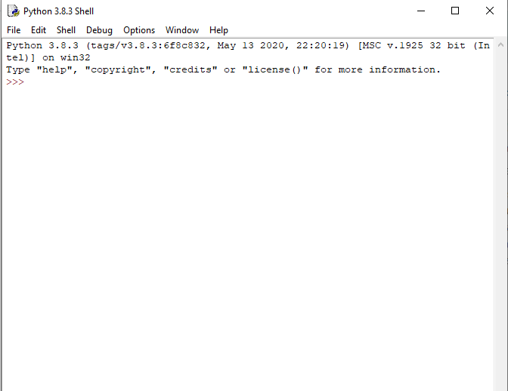

1. **Create GitHub account and connect to the smartbridge repository.**

GitHub**,** Inc**.** is a United States based global company that provides hosting for software development version control using Git.

Projects on GitHub can be accessed and manipulated using the standard Git command-line interface and all of the standard Git commands work with it. GitHub also allows registered and unregistered users to browse public repositories on the site. Multiple desktop clients and Git plugins have also been created by GitHub and other third parties that integrate with the platform. GitHub reports having over 40 million users and more than 100 million repositories (including at least 28 million public repositories), making it the largest host of source code in the world.

Link the github repository of the smartbridge to your github account and upload necessary files and screenshots.

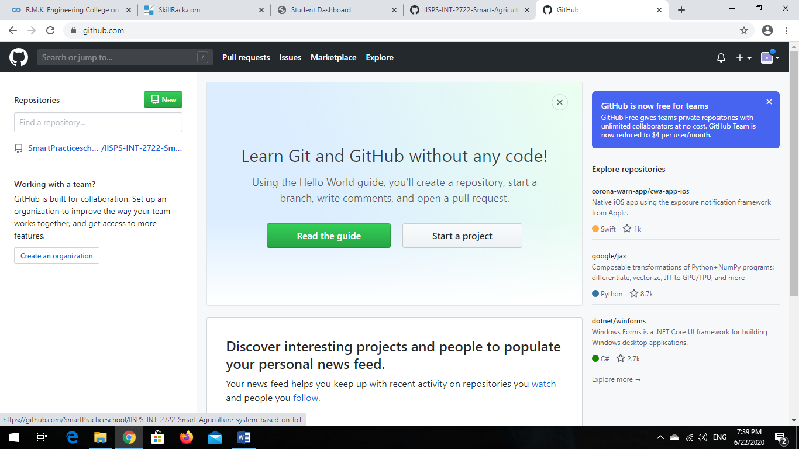

1. **Create IoT devices in IBM IoT platform**

IBM has a large and diverse portfolio of products and services. As of 2016, these offerings fall into the categories of cloud computing, Artificial intelligence, commerce, data and analytics, Internet of Things (IoT), IT infrastructure, mobile, Digital workplace and security.

IBM Cloud includes infrastructure as a service (IaaS), software as a service (SaaS) and platform as a service (PaaS) offered through public, private and hybrid cloud delivery models. For instance, the IBM Bluemix PaaS enables developers to quickly create complex websites on a pay-as-you-go model.

We need to create two devices in the IBM IoT platform, in which one device acts as processor for the sensor information and the other device is used as an instance of the irrigation motors to be operated by the farmer. We also need to generate API keys for the connection, transmission and retrieval of information from and to the devices in the IBM IoT platform.

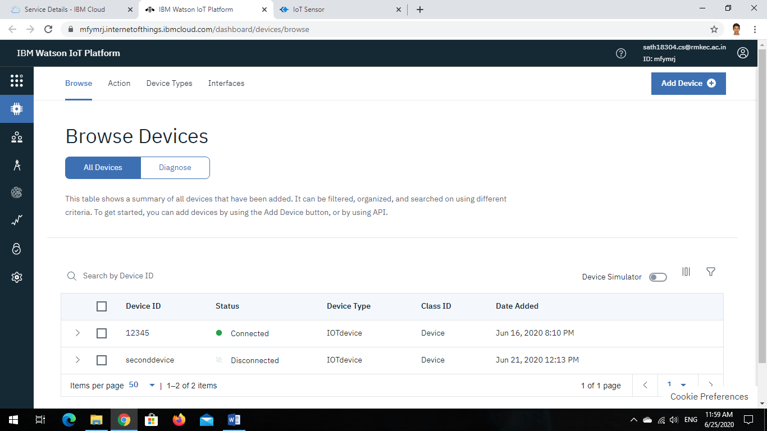

1. **Install Node-red locally in the system**

Node-RED is a flow-based development tool for visual programming developed originally by IBM for wiring together hardware devices, APIs and online services as part of the Internet of Things.

Node-RED provides a web browser-based flow editor that makes it easy to wire together flows using wide range of nodes in the palette that can be deployed to its runtime in a single click. Elements of applications can be saved or shared for re-use. The runtime is built on Node.js, taking full advantage of its event-driven, non-blocking model.

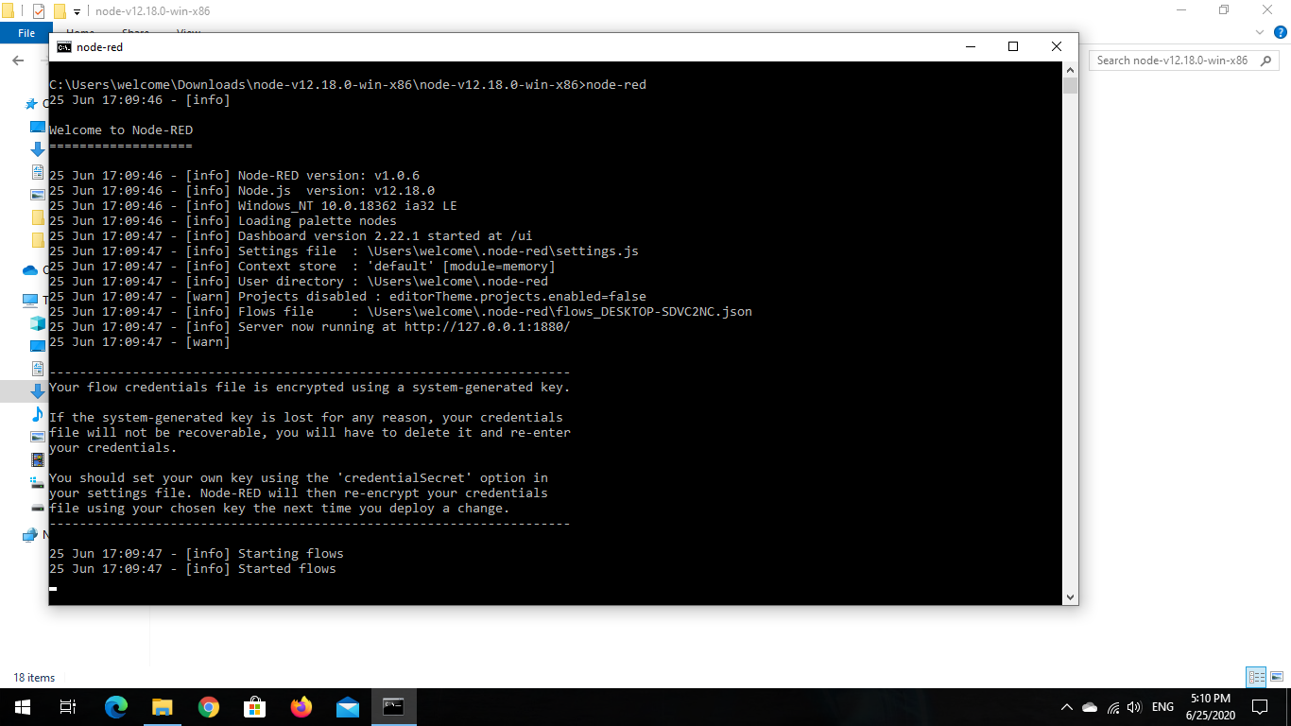

1. **Connecting IoT simulator to the IBM device**

A simulator which simulates the hardware sensors is used to generate the sensor information. The sensor is connected to the IBM device by giving the following credentials

* Device Organisation
* Device Type
* Device ID
* Device Token

Once all the details are given, the simulator gets connected to our IBM device. This can be verified by display of your Device ID in the simulator screen.

The simulator has three boards:

* Temperature for Temperature
* Humidity for Humidity
* objectTemperature for Soil moisture

The simulator sends the data to IBM IoT devices continuously without any time interval.

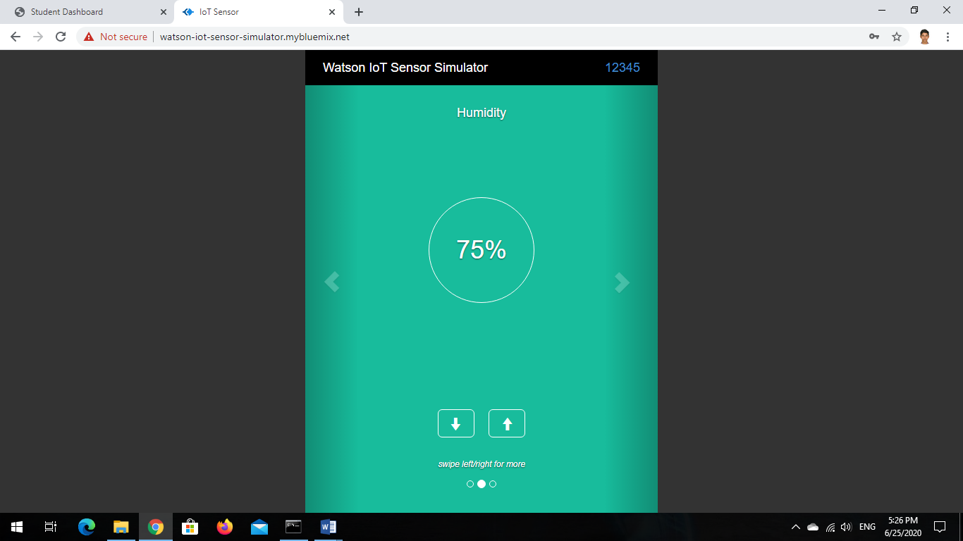

1. **Visualizing the simulator data in IBM IoT Platform**

The IBM IoT platform not only allows you to create and maintain devices but also to visualize them. The board section in the IoT platform can be used to visualize the data received into the devices. Different types of charts and gauges are available to display data in a graphical format.

Any number of cards can be added to the IBM boards section. Any information about the devices and also the data can be visualized in this boards section. The apps section in the IoT platform can be used to maintain the APIs for connecting the IBM devices in the node-red.

The project can be a work of a group of people. So the project head can assign different roles to different people in the team. This work assigning can be done in the access management section in the IoT platform. The usage section shows the data usage summary.

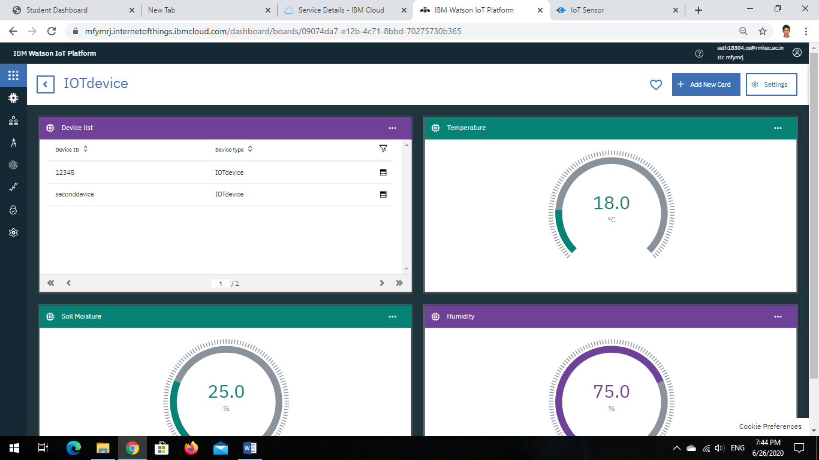

1. **OpenWeatherMap API**

The OpenWeatherMap is a tech company which provides weather and satellite data worldwide. Initially an account must be created in the OpenWeatherMap website. Once an account is created an API key is generated automatically otherwise you can create one by selecting API keys tab in the website. The API key is copied and saved. The API can be used to send a HTTP request from node-red to get the weather forecast details for any location as per your wish. When the API is used as a HTTP request in a web browser, OpenWeatherMap will send the forecast details in a JSON object which will be displayed on the screen. When the URL is used in a node-red HTTP request node, it will receive the same JSON object on which operations like data manipulation and visualization can be done with the help of function, change nodes and gauge, chart nodes respectively.

1. **Designing the User-Interface using Node-red**

By default, the node-red’s node palette will contain some basic nodes.

According to our need we can install extra nodes. For this project we require Dashboard nodes to design the user-interface and IBM IoT nodes to send and receive information, events and commands from and to the IBM IoT devices.

You can use variety of dashboard nodes to display the obtained information in a very colorful and catchy way in a User-interface. The dashboard can be customized to many variety of colors. The layout of the interface can also be changed and modified.

1. **EXPERIMENTAL INVESTIGATION**

**Device Creation in IBM IoT Platform**

The project requires IoT sensors in the field to get the Temperature, humidity and soil moisture. The sensors are simulated by an IoT sensor simulator which simulates the above said data values. But still the values must be stored or passed on to some IoT device. This IoT device is created in the IBM IoT Platform. Steps to create IBM IoT device:

* Launch the IBM IoT Platform and go to the Devices section.

Initially when you visit the section first time, there will not be any devices available. So you need to create a new device.

* Click on the Add New Device button.
* First type the device type which is IOTdevice.
* Then type the device id which is the name of the device
* Next is the device information which includes information like Serial number, model, Manufacturer and hardware version etc. Since we are going to use Online Simulator, these details need not be filled.
* Then comes the creation of authentication token which is the device password.
* Then click on Next where you can see the summary of the created device.
* Click on Finish and the device will be created successfully.

**Board Creation in IoT Platform**

The data is sent to the IBM devices. But the way of looking at the data can change the way of solving problems; when you just simply store the data coming from the source, the insights are not much easily visible. So visualization of data helps in getting useful insights from the data. The data can be visualized in the form of charts and gauges. To create boards follow the given steps:

* The charts and visualization can be done in the Boards section on the left side of the IoT Platform.
* First a board must be created where you can display the cards.
* Click on Create New Board option to create a board.
* Type in the boards name and description and click Submit.
* Once the board is created, you can create as many as cards you want.
* Click on Add New Card and select the card type which can be a chart or a gauge.
* Now select the device from which the data needs to be visualized.
* Next you can select the size of the card.
* Finally give the card name and color and click on Submit.

The card will be displayed in your board with the data from the device.

**Simulator in IBM IoT Platform**

The sensor data can be simulated by an online simulator as well as by a Simulator in IBM IoT Platform itself. There is an inbuilt simulator available in IoT platform. To start a simulation click on the device simulator option above the devices created. Now a small tab will open showing “0 Simulations running”; click on that to open the Simulator dialog box. Now follow the steps to create a simulation:

* Now click on the Create Simulation button
* Enter the device type that is the type of your created device
* Now schedule the payload interval and also you can modify the payload with the data variables you need.
* Click Save to save the event
* Then click on Registered device.
* Select the device to which the simulation data must be sent.
* Once the device is selected the data will be sent to the device.

1. **Flowchart**

Node-red is a browser based flow editor. It helps in connecting the devices and softwares to one another. It is most prevalent in IoT projects where it is used to connect the devices, cloud and user-interface etc. The nodes are built using node.js language. In this project, node-red is used to connect the IBM devices and display the data in a user-interface; make an HTTP request to OpenWeatherMap platform to obtain the weather forecast details and also subscribe to the IBM device to receive commands with the a python code running in the background.

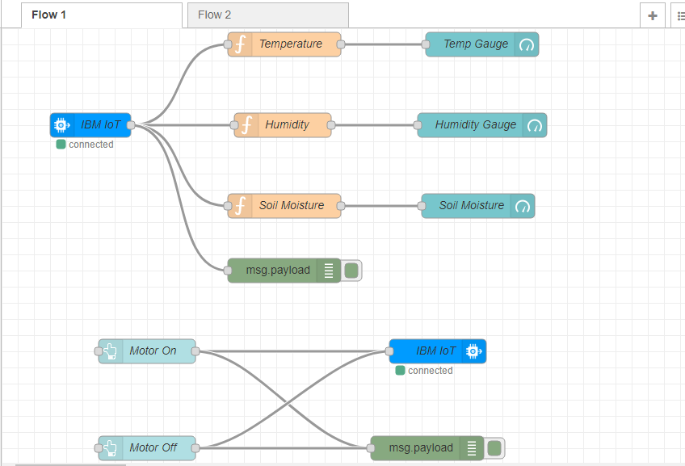

The Node-red flow has three subflows:

1. Field Sensor - The data obtained from the simulator and stored in IBM device. An “IBM in” node is used to obtain the data from IBM device into the node-red. Then the payload of “IBM in” node is passed to “function” nodes to separate the data into Temperature, Humidity and Soil Moisture separately and display it in the User-interface with the help of “Gauge” nodes.
2. Motor Controls - The commands used to control the motor by subscribing to IBM device by python code. The “button” nodes are used to create the buttons and are connected to “IBM out” node which is configured to receive commands. When the button in the User-interface is clicked the command will be printed in the Python IDLE.
3. Weather Forecast - The weather forecast details obtained from OpenWeatherMap API call. An “http request” node is used to make the API call to OpenWeatherMap platform. The payload of the request node is then segmented into different data like Location, Forecast, Temperature, Pressure, Humidity, Wind Speed with the help of “change” and “function” nodes and displayed in the User-interface by using “text” and “gauge” nodes.

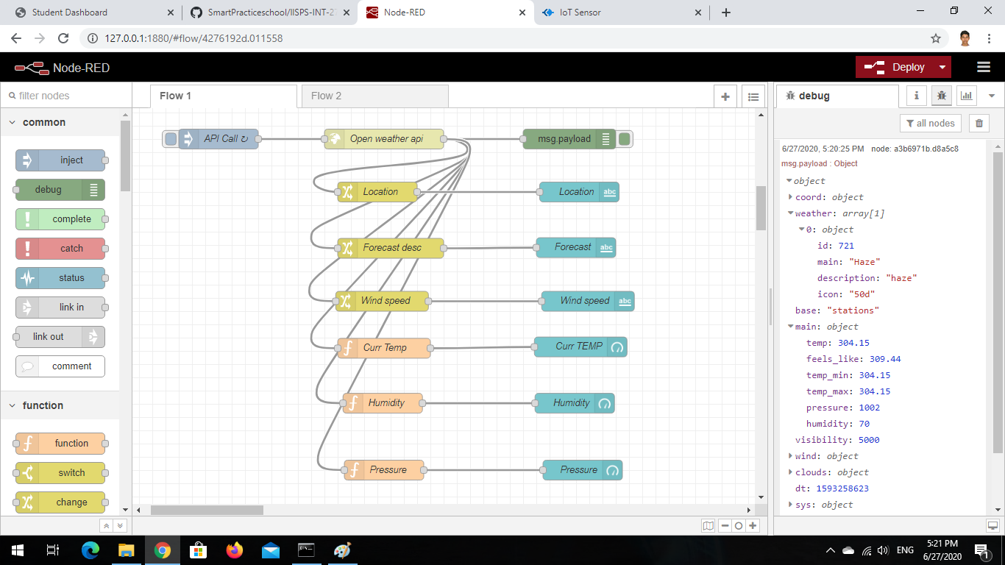

1. **RESULT**

Once the node-red flow is deployed, the data transfer between devices and node-red starts. Events that are taking place:

1. The online simulator starts simulating field sensor data and sends it to the IBM IoT Platform.
2. The node-red flow obtains the data from IBM device and is visualized in the user-interface.
3. The OpenWeatherMap API call is made using http request from node-red and retrieves the weather forecast details.
4. The forecast details are visualized in the user-interface.
5. The buttons when clicked send the respective commands to the motor.

Thus the project is deployed successfully.

1. **ADVANTAGES AND DISADVANTAGES**

Smart agriculture system using IoT will be very useful for farmers. Some of the advantages are:

* Due to the physical objects getting connected and controlled digitally, there is a lot of automation in the working.
* More information helps to make better decisions.
* It is easy to monitor and control the system.
* The cost of travel is eliminated and time is also saved.
* Maintenance is easier and simpler.
* The location of the end user becomes irrelevant because of the internet technology which allows to be operated from anywhere

Some of the disadvantages are:

* Error in data received can make the end user take a bad decision.
* Any failure or bugs in the software or hardware will have serious consequences.

1. **APPLICATIONS**

The IoT technology has wide range of applications in various fields and events of life. With the power of internet anything is made possible in IoT. The main components in any IoT system are sensors, devices, cloud platform, and connectivity.

IoT in agriculture can do many things and improve the crop yield to a whole new level. Some of the applications are:

* Autonomous tractors for ploughing, tilling and planting seeds.
* Data sensors for better maintenance and cultivation
* Drones for spraying pesticides and insecticides

1. **CONCLUSION**

Smart Agriculture system is an IoT based system which leverages the modern technology for the betterment of the farmers in many ways. Agriculture in India has got a very long history, starting from the early civilizations in India. About 60% people in India are engaged in agriculture and its related works. Farmers are heavily dependent on rain; but due to unpredictability of rain, most of the farmers are unable to make better yield. So this system displays the current and forecast weather making it easy for the farmers to decide about the irrigation timings and amount of water for irrigation.

1. **FUTURE SCOPE**

The project can be improvised with drones to monitor the pests and diseases. The model can be further automated like based on the data received the motor will be turned on or off automatically. The mineral content of the soil can be tested and accordingly crops can be cultivated. The IoT can be leveraged to obtain better crop yield and minimise the physical labor of the farmers by automating many processes.